**Functionality Description**

**For**

**[SP Movies 2.0]**

**Date: [05/02/2023]**

**Contents**

1 Document Management 3

*1.1* *Contributors* 3

*1.2* *Version Control* 3

2 OVERVIEW 4

2.1 Function Description 4

2.2 Technology 11

2.3 Development Tools and Processes 12

2.4 Interfaces and services 13

3 APPENDIX 15

3.1 Additional / Advanced features 15

3.2 Reference Links 16

# Document Management

## *Contributors*

*Details of all contributors to this document*

|  |  |
| --- | --- |
| **Function Integrated** | **Name** |
| Functions #1,2,3 | Ng Cheng Wai Melvin |
| Function #4 | Kua Zi Lin |
| Function #5 | Ng Chye Yong |
| Functions #6, #7 | Ng Cheng Wai Melvin |
| Additional functions/features | Ng Cheng Wai Melvin |
|  |  |

## *Version Control*

*Changes made to this document since creation.*

|  |  |  |  |  |
| --- | --- | --- | --- | --- |
| **Date** | **Version** | **Author** | **Section** | **Amendment** |
| 01/02/23 | 1.0 | Melvin | - | Initial Creation |
| 03/02/23 | 1.1 | Kua | 2.1 | Update Function 4 Function Description |
| 03/02/23 | 1.2 | NG CY | 2.1 | Update Function 5 Function Description |
| 04/02/23 | 1.3 | Kua | 2.4 | Update Function 4 Interface & Service |
| 04/02/23 | 1.4 | NG CY | 2.4 | Update Function 4 Interface & Service |
| 04/02/23 | 1.5 | Melvin | 3.1, 3.2 | Add new sections & Tidy up document |
| 04/02/23 | 1.6 | Melvin | 2.1 | Fix minor typos |
| 05/02/23 | 1.7 | Melvin | 2.1 | Update Functions 1-3 Function Description |
|  |  |  |  |  |
|  |  |  |  |  |
|  |  |  |  |  |

# OVERVIEW

*A brief description of what the overall system is about from a business perspective.*

## Function Description

*High level description of what functionality the system contains (a list of the components / functionalities that have been integrated (frontend ↔ backend)).*

*This should include*

*i) a sequence diagram of the input / output between the User, Front End (i.e. the Website) and the Backend (i.e. the Server App).*

*ii) screenshots of the end to end process (i.e. what would be observed by the User)*

1. **Function #1 – Login and Access control (Admin user & Normal user)**

* When the web application is initially loaded, you will be initially shown a login screen. Using this particular login functionality, an admin or normal user will be able to login & if successful, they will be able to access the other web pages / functionalities of the web app. An error message will be shown instead if login fails.
* FYI:
  + Admin user: Has ALL the privileges (able to access ALL functionalities of the application)
  + Normal user: Has only LIMITED privileges (only able to access SOME functionalities)
  + Not logged in admin/user: NOT ABLE to access any functionalities (only shown a login page by default)



* Before login (Admin / Normal user):

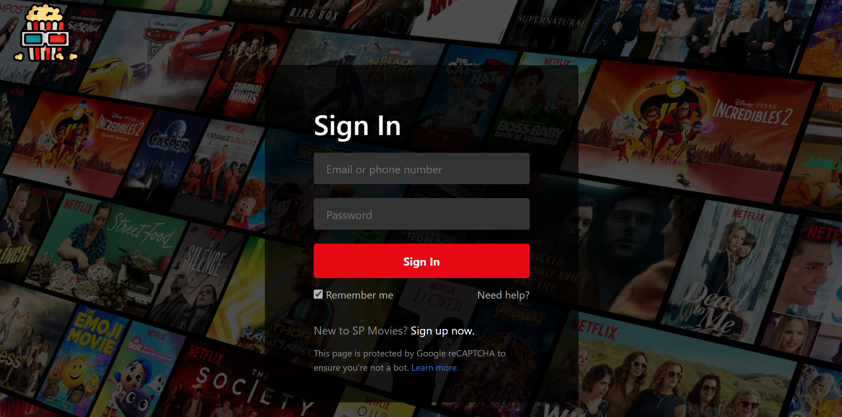

* Successful login (Admin):

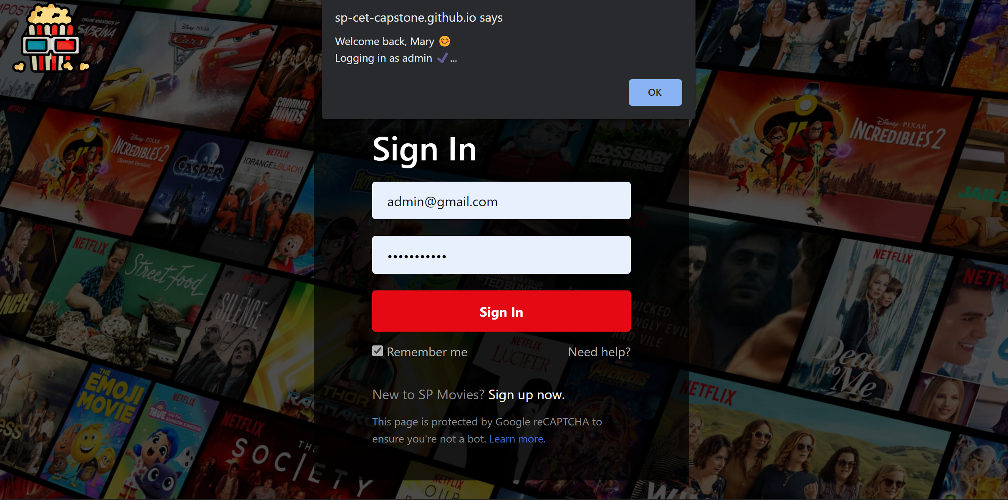

* Successful login (Normal User):

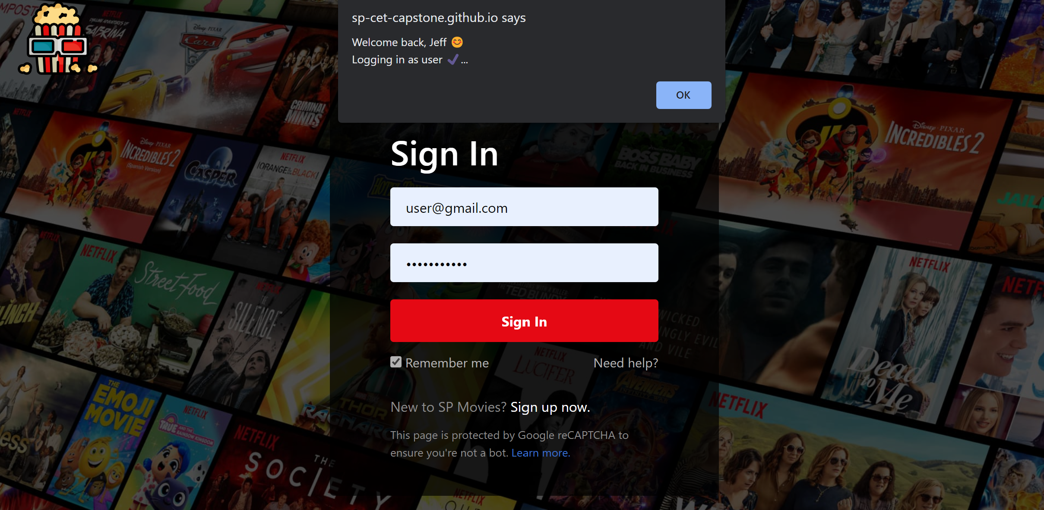

* Failure to login (Admin / Normal User):

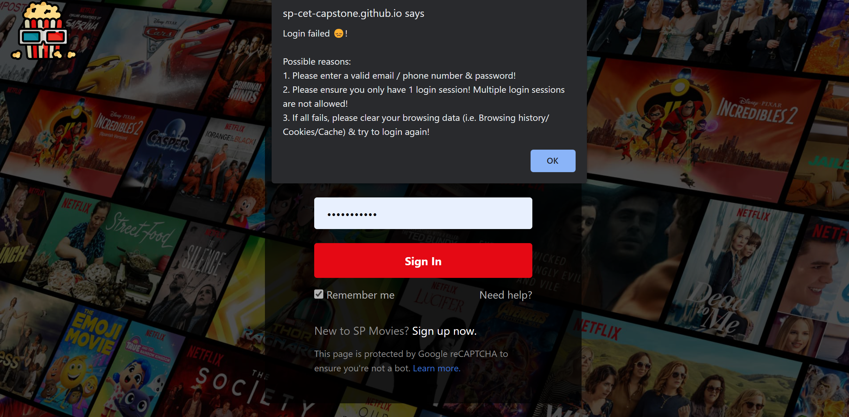

1. **Function #2 – Retrieve and display a list of movies (Admin user & Normal user)**

* Once the user is logged in, the user can use this functionality to retrieve the latest movies from the server / database and then display it. The order of the movies displayed is based on its own respective ‘movieID’ found in the ‘movie’ table of the database (ASC order).
* The user can also click on the ‘Retrieve Movie’ option in the navigation bar to execute the same functionality that fetches & displays a list of movies.



* A) On successful login OR B) If user clicks on ‘Retrieve Movie’ option:

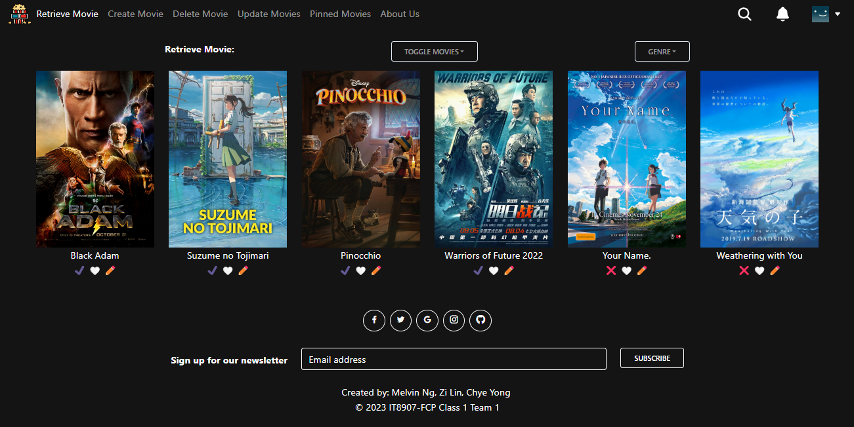

* If the GET /movies API endpoint fails to retrieve & display a list of movies:

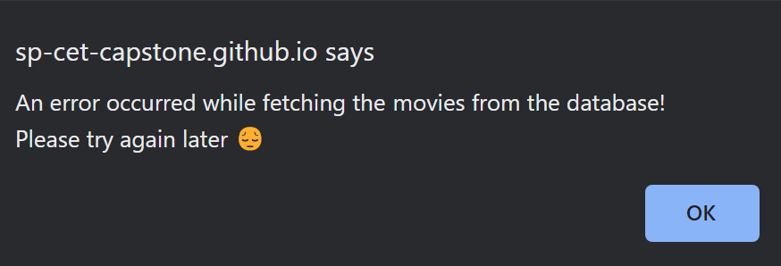

1. **Function #3 – Update Movie details (Only for Admin)**

* Once the admin is logged in, the admin can use this function to update movie details for any particular movie.
* The updated movie details will be sent as a payload to the server and database for processing. If the update is successful, that particular movie will be updated in the database with the new movie details.
* When the user subsequently clicks on the ‘Retrieve Movie’ option in the navigation bar to go to the homepage, he/she will be able to see the updated movie details over there.

**

* Admin clicks on ‘Update Movies’ option in navigation bar (4th option from left; highlighted):

**

* The admin will then be directed to the ‘Update Movies’ webpage. Click on any of the movies listed there to update that particular movie:

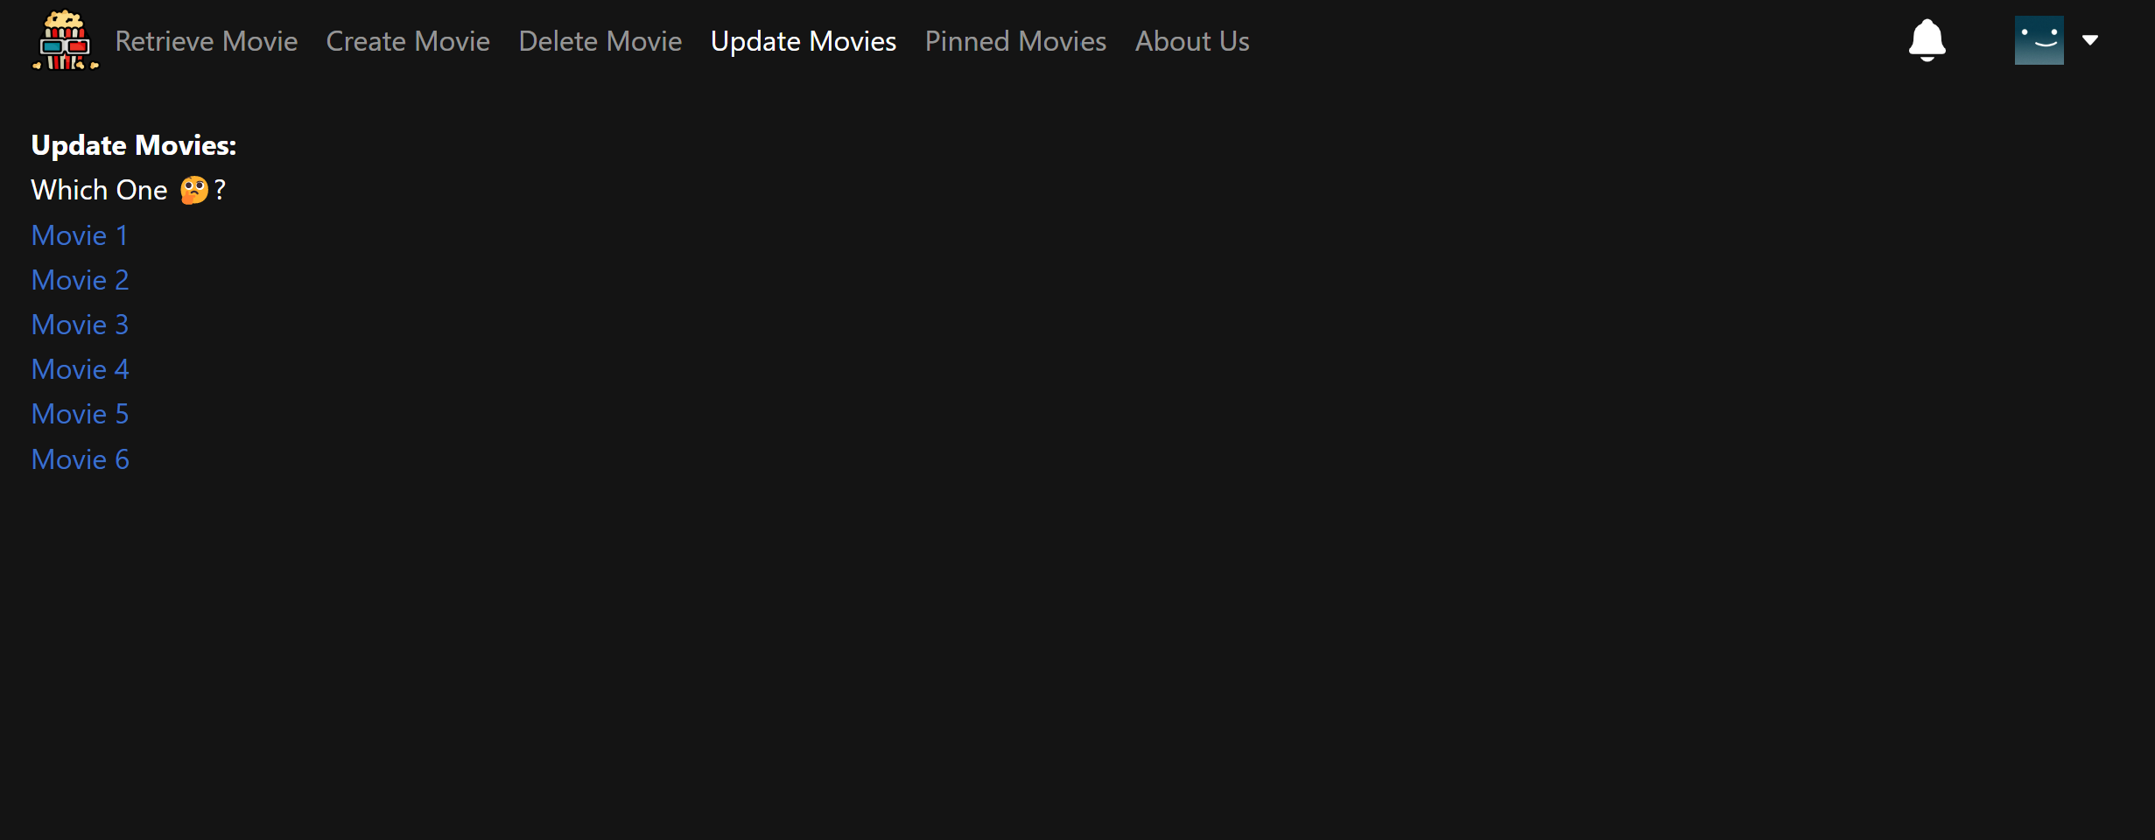

* For example, if we click on ‘Movie 1’ option (from the previous screen), we will be directed to a webpage that contains a form to update Movie 1 specifically:

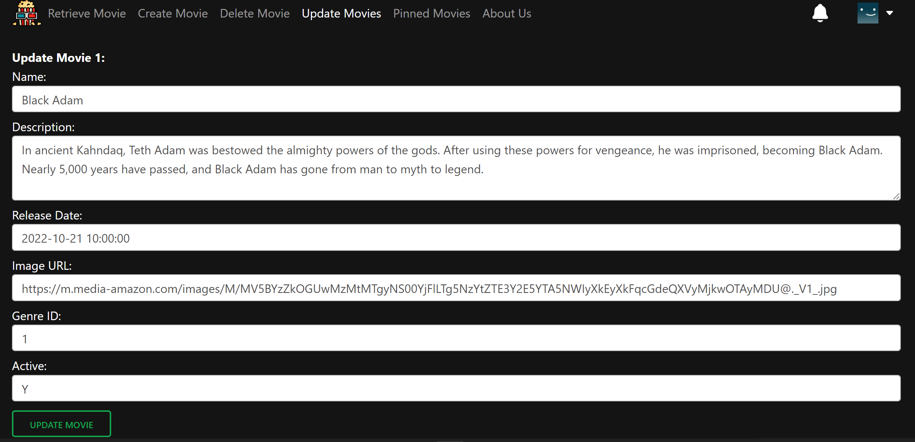

* Enter the new movie details you wish to update in the database. Once completed, press the ‘Update Movie’ button at the bottom of the form.

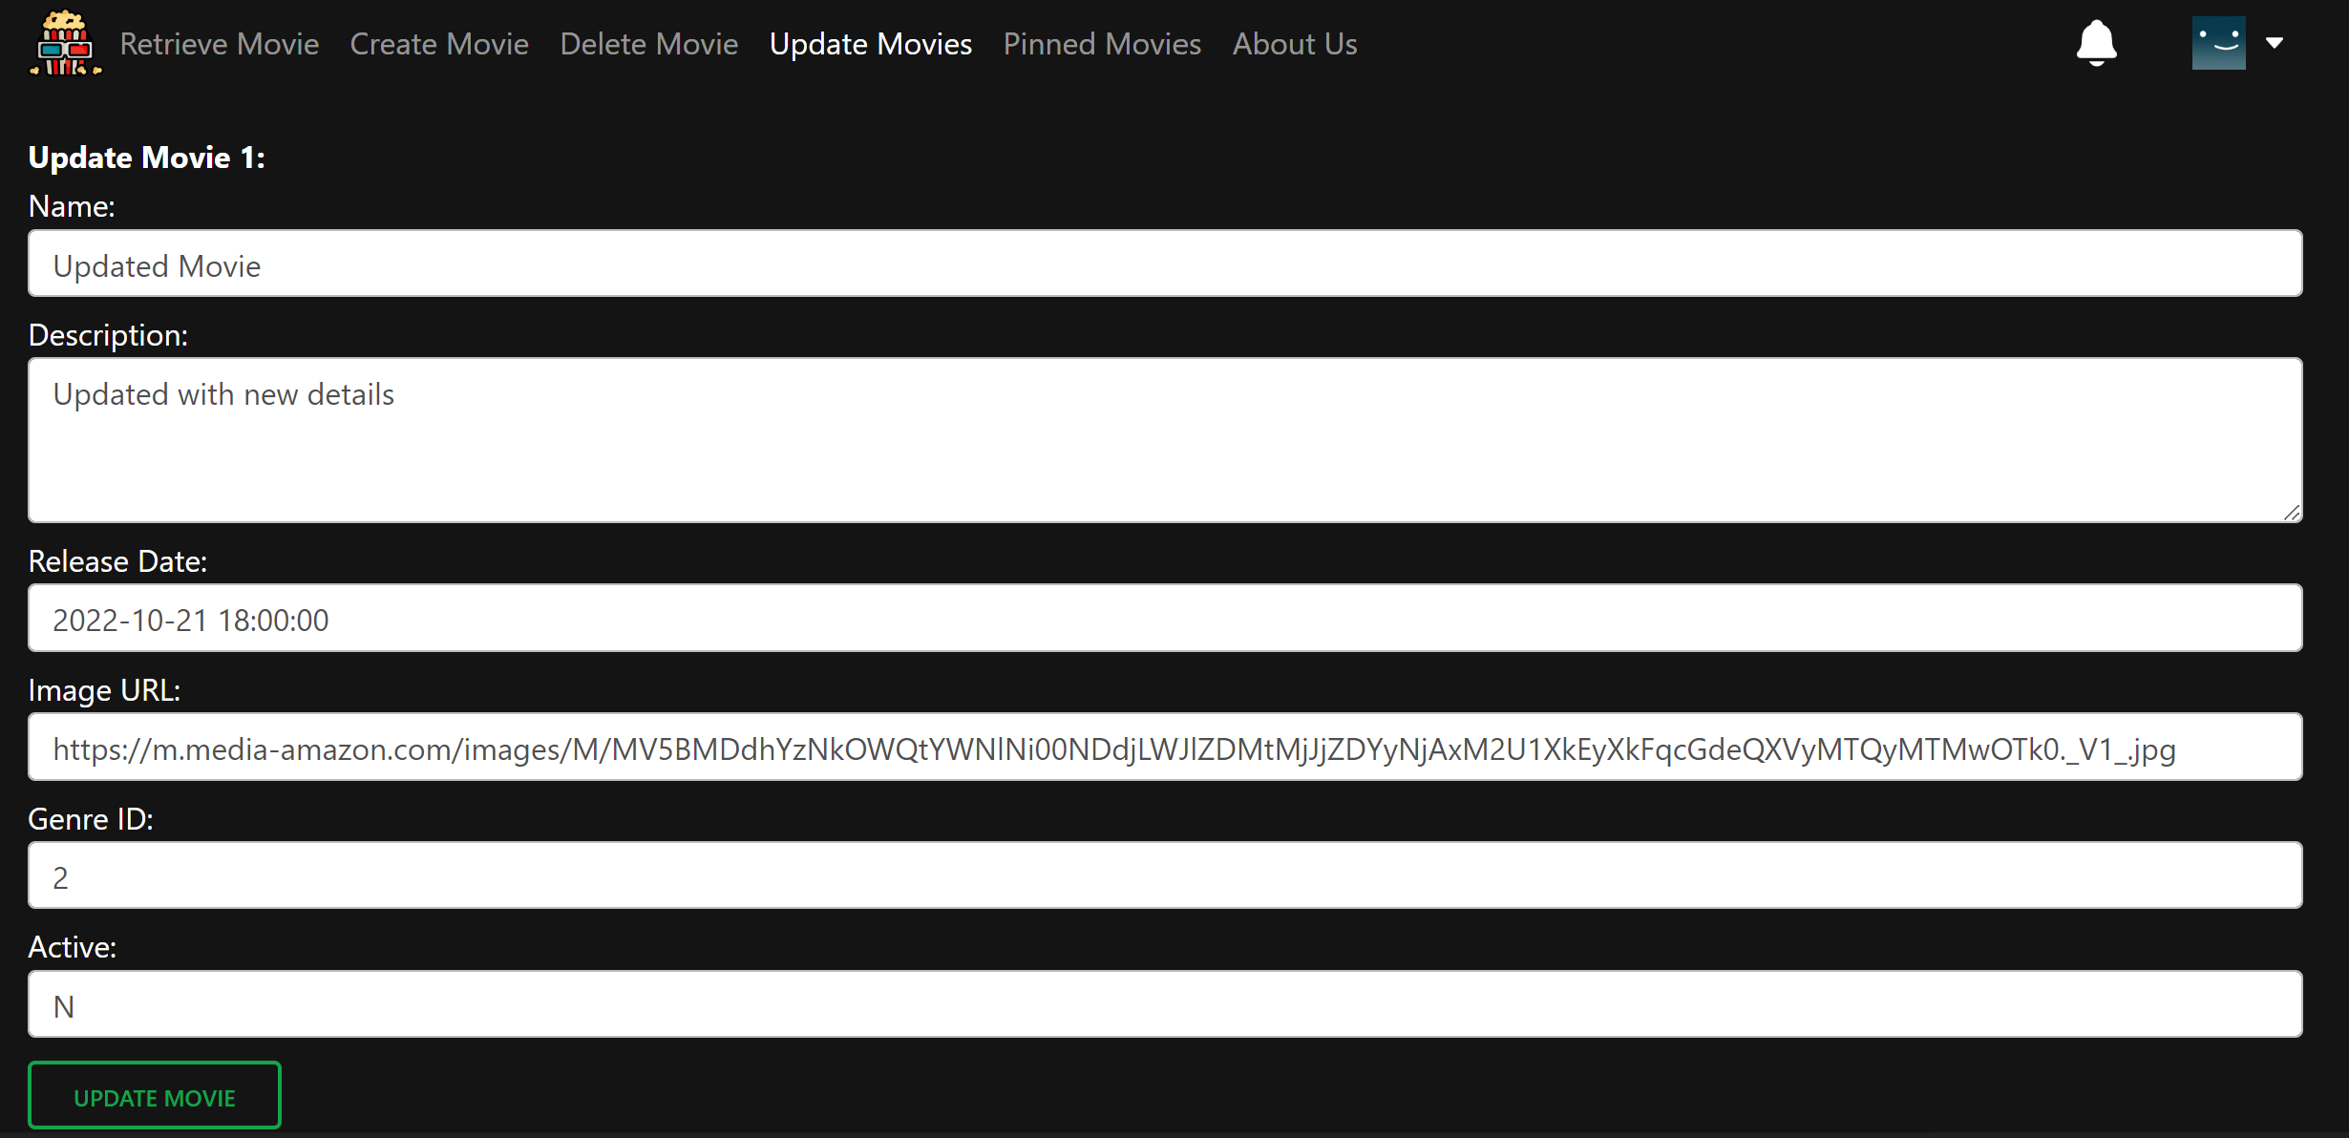

* The movie details payload will first be validated. Once validated, then we will send the payload to the server/database for processing – and an alert message will first inform you if the validation is successful or not.

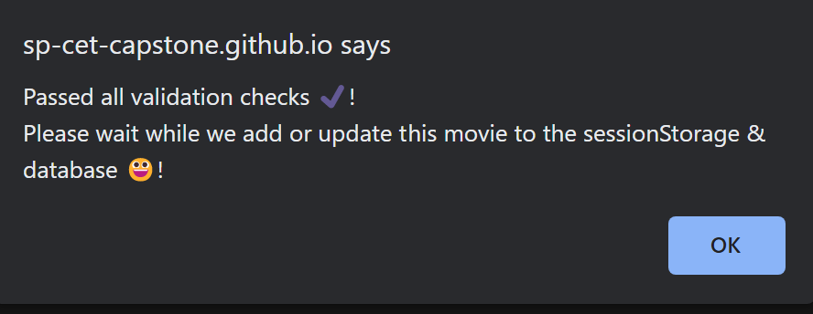

* Once the movie is successfully updated in the database, an alert message will then pop up to notify the admin.

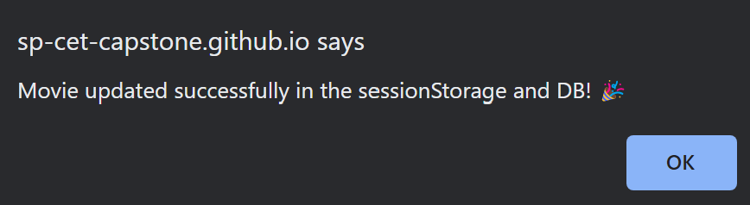

* When the admin clicks on the ‘Retrieve Movie’ option or the SP Movies logo in the navigation bar, he/she will see the updated movie details over there:

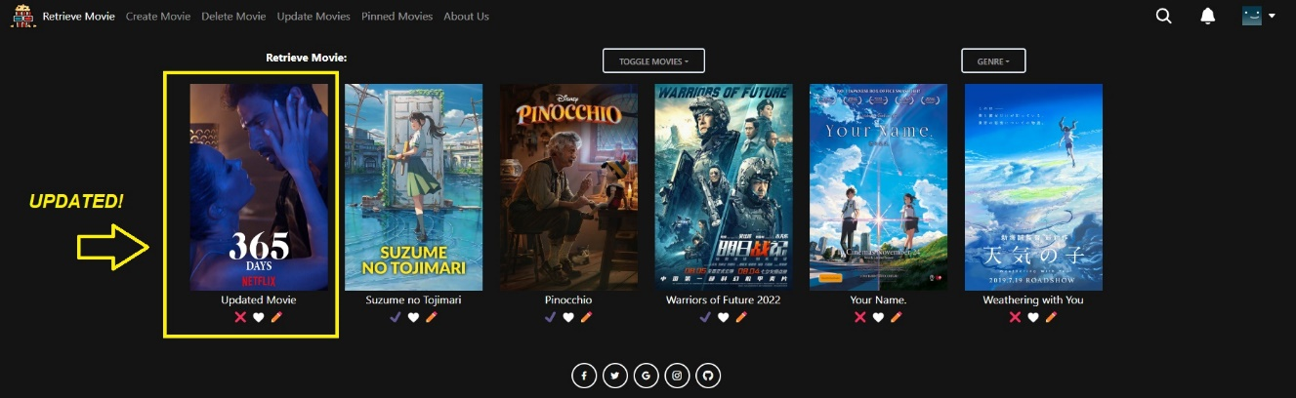

* If the PUT /movies/:movieID API endpoint fails to update the movie:

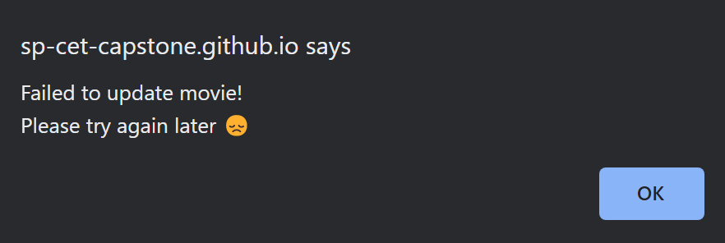

1. **Function #4 - Retrieve Movies and Sorting Z to A (Admin user & Normal user)**

* Once the user is logged in, the user can use this function to retrieve the latest movies from the server / database and then display it in reverse alphabetical order (Z to A).



* Before Sorting Z-A:



* 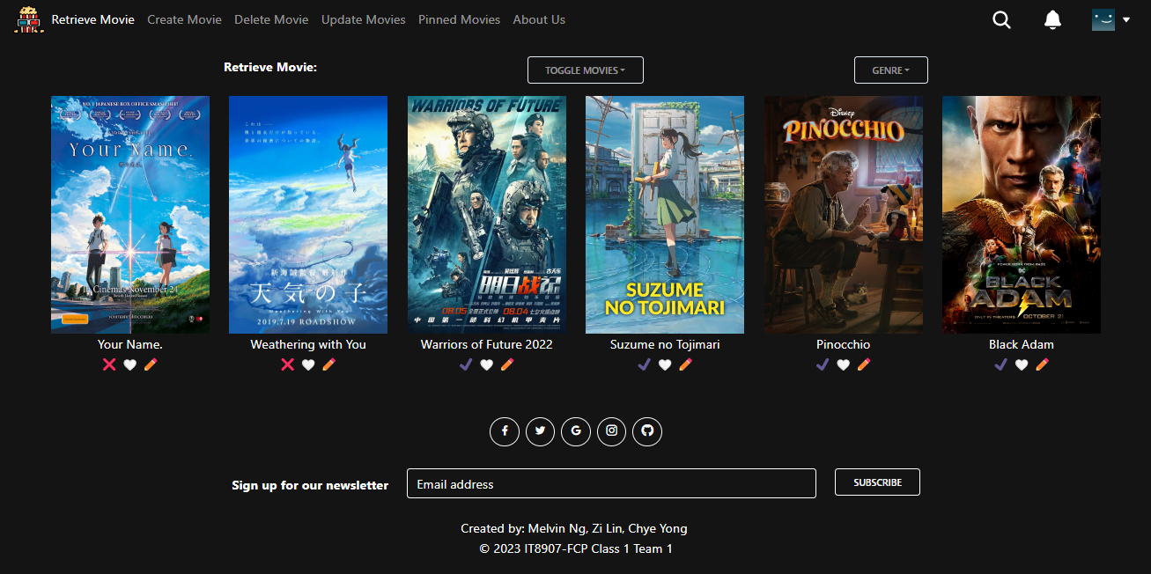After Sorting Z-A:

1. **Function #5 - Retrieve Movies and Sorting A to Z (Admin user & Normal user)**

* Once the user is logged in, the user can use this function to retrieve the latest movies from the server / database and then display it in alphabetical order (A to Z).

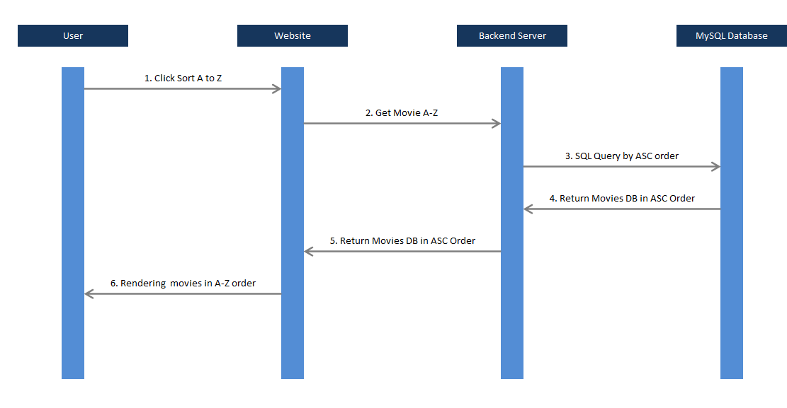

* Before Sorting A-Z:



* 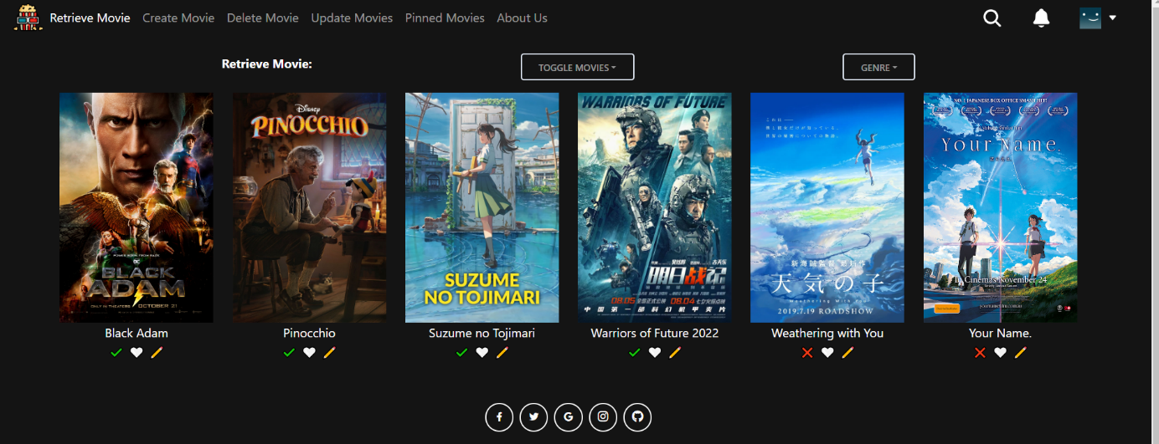After Sorting A-Z:

...

## Technology

*A listing and brief description of the underlying frameworks / libraries used by the application.*

## Development Tools and Processes

*This section should be used to document:*

* *any specific development tools, compilers or suggested IDEs that are used for the application.*
* *Describe how software source control is performed (e.g. Git)*

## Interfaces and services

* List all backend interfaces (incoming – data into the backend, outgoing – data out of the backend) and the path to the file (and lines of code) in which they are stored in.

| **Function Integrated** | **Details of Front End Codes** |  | **Details of Back End Codes** |
| --- | --- | --- | --- |
| Function #1 | Function.jsx (lines 20 to 30) | <-> | App.js (lines 10 to 15) |
| Function #4  (Retrieve & Sorting Z to A) | src/components/RootPage/Index.jsx  (lines 19-24 , 96-98 , 116-118) | <-> | controller/app.js  (lines 183-193) |
| src/redux/movieSlice.js  (lines 62-79 , 112-128) | model/movie.js  (lines 180-202) |
| src/utils/functions.js  (lines 439-461) |  |
| Function #5  (Retrieve & Sorting A to Z) | Src/components/RootPage/Index.jsx (lines 19-24, 88-90, 105-107) |  | controller/App.js (lines 171-181) |
| Src/redux/movieSlice.js (lines 44-60, 92-107) |  | model/movie.js  (lines 27-50) |
| Src/utils/functions.js (lines 404-432) |  |  |
|  |  |  |  |

# APPENDIX

A brief description of what the additional / advanced features that were added in as well (beyond the scope of the CA1/CA2 requirements)

## Additional / Advanced features

High level description of what other additional / advanced functionalities the system contains.

This should include

i) a general description of the functionality in words.

ii) screenshots demonstrating how the functionality works (i.e. what would be observed by the User)

## Reference Links

For additional information, please kindly refer to the following links below:

* GitHub Repository Link : <https://github.com/SP-CET-Capstone/capstone-assignment-class-1-team-1>
* README.md (**Important** for understanding the web app & login credentials are also listed there): <https://github.com/SP-CET-Capstone/capstone-assignment-class-1-team-1/blob/main/README.md>
* Our group’s Kanban Board: <https://github.com/orgs/SP-CET-Capstone/projects/11>
* Roles & Responsibilities of each team member (we worked together like a Scrum team): <https://github.com/orgs/SP-CET-Capstone/projects/11?pane=issue&itemId=19145533>